**Write a C program to implement the application of Stack (Notations)**

**INPUT:**

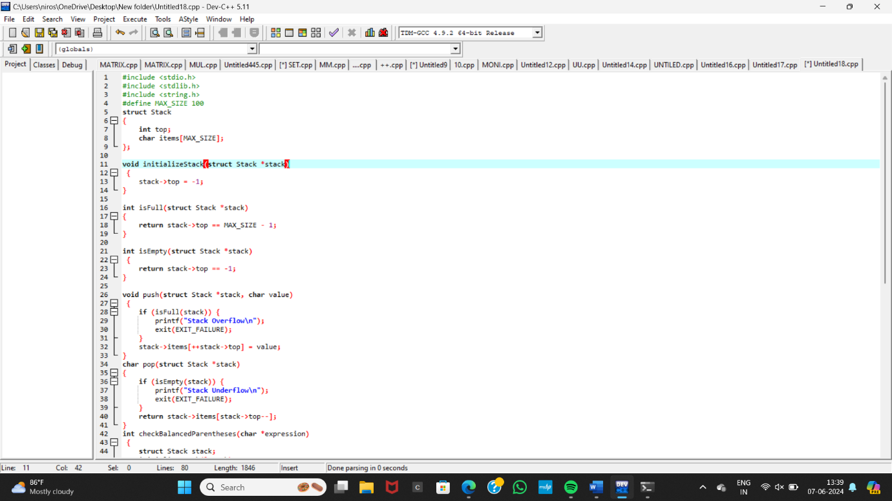

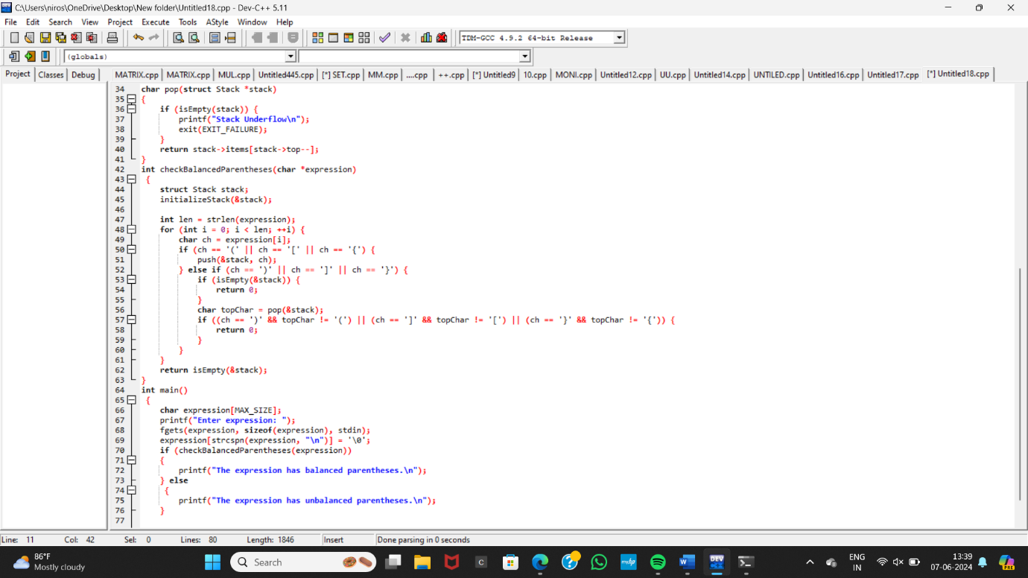

**OUTPUT:**

